Physics LW#7 How to synthesize (make) soap from oil and caustic soda

The main stages of a chemical synthesis

1. Chemical reaction
A synthesis allows us to create a chemical thanks to a reaction between chemical reagents.
A soap is formed when oil reacts with a basic solution, such as caustic soda.
The
caustic
soda has a
very high
Concentration:
It is absolutely necessary
to respect the safety instructions :
Tie back long hair
Close your lab coat
Wear gloves and goggles
Experimental setup : The reflux
Carefully insert into the boiling flask:
- 15 mL of oil,
- 20 mL of caustic soda,
- 20 mL of ethanol
- add 4 or 5 pumice stones (pierre ponce).
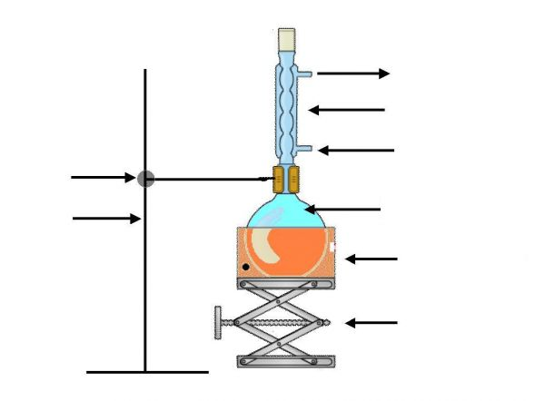
Switch on the water flow inside the condenser. Then switch on the heater at its maximum value. When the mixture starts boiling, decrease the heater to a medium value.

Drawing of a reflux set up

Use of the heater:
Use of the condenser:
Use of the lab jack:
Use of the pumice stones:
Use of ethanol (it is not a catalyst):

2. Separation of the product: solidification and filtration

- solidification :
Experimental procedure : Pour the mixture of the boiling flask into a large beaker filled with iced salted water.

Observation :

Explanation:
Chemical species | Oil | Caustic soda | soap
Solubility in water | Liquid  that is not miscible  in water | Soluble | Soluble
Solubility in salted water | Liquid  that is not miscible  in water | Soluble | A little soluble
Solubility in iced salted water | Liquid  that is not miscible  in water | Soluble | Not soluble

- filtration :

3. Cleaning (We won't have enough time to do this part) Rinse the soap with water (if necessary, make another solidification process)

4. Identification Put a small piece of soap ( ! do NOT touch the soap!) inside a test tube, add water, close the test tube with a stopper and shake it.
Observation and conclusion :
Theoretical study
1. The reaction mechanism of saponification contains three elementary reactions.
- Complete each step: circle the donor site in blue, and the acceptor site in red. Draw a green curved arrow to show the movement of electrons from one site to another.
- Name each elementary reaction among: addition, elimination, acid-base reaction

1st step:
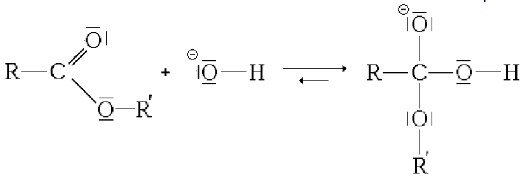
2nd step:
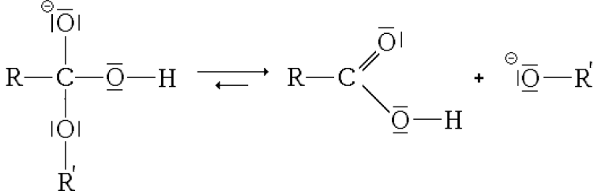
3rd step:
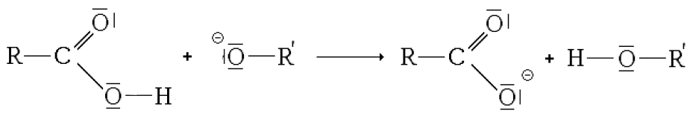
2. reaction yield (rendement)
When writing a fully balanced chemical equation, it is assumed that all of the reactants will be converted into products. If this were the case, then the yield would be 100%. However, in practical work, yields of 100% are rarely obtained.
The percentage yield is (formule à connaître)

Calculate the reaction yield of the saponification knowing that:
- The soap we obtain after cleaning and drying has a mass: m = 10,2 g
- The olive oil's density is: d = 0,90
- The caustic soda is a solution of sodium hydroxide at 30,5% in mass
- The caustic soda's density is: d = 1,33
- The water volumetric mass is : ρ = 1000 g/L
- The atomic molar masses are: M_{C} = 12 g/mol ; M_{H} = 1 g/mol ; M_{O} = 16 g/mol ; M_{Na} = 23 g/mol

Aide : Calculer les quantités de matières initiales ; puis calculer la quantité de savon maximale qu'on pourrait obtenir (si besoin, dresser un tableau d'avancement).
Calculer la quantité de savon obtenue.
Theoretical study
1. The reaction mechanism of saponification contains three elementary reactions.
- Complete each step: circle the donor site in blue, and the acceptor site in red. Draw a green curved arrow to show the movement of electrons from one site to another.
- Name each elementary reaction among: addition, elimination, acid-base reaction

1st step:
2nd step:
3rd step:
2. reaction yield (rendement)
When writing a fully balanced chemical equation, it is assumed that all of the reactants will be converted into products. If this were the case, then the yield would be 100%. However, in practical work, yields of 100% are rarely obtained.
The percentage yield is (formule à connaître)

Calculate the reaction yield of the saponification knowing that:
- The soap we obtain after cleaning and drying has a mass: m = 10,2 g
- The olive oil's density is: d = 0,90
- The caustic soda is a solution of sodium hydroxide at 30,5% in mass
- The caustic soda's density is: d = 1,33
- The water volumetric mass is : ρ = 1000 g/L
- The atomic molar masses are: M_{C} = 12 g/mol ; M_{H} = 1 g/mol ; M_{O} = 16 g/mol ; M_{Na} = 23 g/mol

Aide : Calculer les quantités de matières initiales ; puis calculer la quantité de savon maximale qu'on pourrait obtenir (si besoin, dresser un tableau d'avancement).
Calculer la quantité de savon obtenue.

